Lesson 01 XAS Resource Workbook

**Photoelectric Effect, Absorption, and Fluorescence**

**Charles A. Cardot and Gerald T. Seidler**

*All lessons and all versions can be found at* [*https://github.com/XASResourceWorkbook/XASResourceWorkbook*](https://github.com/XASResourceWorkbook/XASResourceWorkbook)

*This work is licensed under* ***CC BY-NC-SA 4.0***

**

Version History:

1.0 May 2021: C.A. Cardot, G.T. Seidler

Lesson 01 XAS Resource Workbook

**Photoelectric Effect, Absorption, and Fluorescence**

**Suggested Introductory Reading**

* Newville “Fundamentals of XAFS”, (Sections 1 and 2),. <https://millenia.cars.aps.anl.gov/xraylarch/downloads/2018Workshop/NewvilleEXAFS_RIMG78_ColorPreprint.pdf>
* Wikipedia ‘The Photoelectric Effect’, [https://en.wikipedia.org/wiki/Photoelectric_effect](https://en.wikipedia.org/wiki/Photoelectric_effect%20)

X-ray absorption spectroscopy (XAS) is a 100-year-old technique whose roots span the quantum revolution of the early 20th century. For background, it is useful to consider some of this early history, especially since many of these topics are either useful context for later lessons or else are themselves the focus of later lessons:

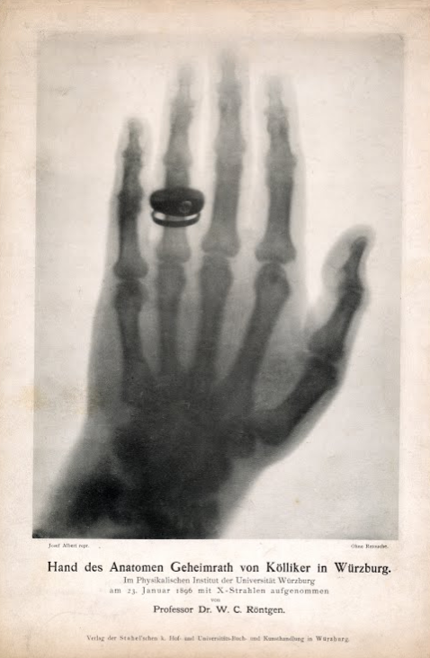

One of Roentgen’s earliest x-ray images, <https://en.wikipedia.org/wiki/Albert_von_K%C3%B6lliker>.

* In 1895 Roentgen reported the discovery of x rays, where the name ‘x rays’ was chosen with deference to ‘x’ being the variable to describe something unknown, <https://doi.org/10.1038/053274b0>. There was indeed considerable initial confusion about x rays, including the unfortunate story of ‘N rays’ <https://en.wikipedia.org/wiki/N-ray>. Significant work in the early 20th century established that x-rays were short wavelength electromagnetic waves, such as is described in Compton’s Nobel Prize lecture, “X-rays as a Branch of Optics,” https://www.nobelprize.org/uploads/2018/06/compton-lecture.pdf
* The photoelectric effect safely predated both the discovery of x-rays and the quantum revolution. For example, in the 1880’s Heinrich Hertz and collaborators more clearly identified the heuristic conditions and phenomenology of the photoelectric effect and also made use of it for quantitatively detecting light. It was only later that Thomson

identified that the ejected particles in the photoelectric effect were indeed the same as those in cathode rays (i.e., electrons), and subsequently that Einstein proposed the corpuscular theory of light via the photoelectric equation <https://doi.org/10.1119/1.1971542> , for which he received the Nobel Prize. As you are likely aware, this idea was controversial for many years, and the photoelectric equation was only finally accepted after many years of detailed work by Milliken, whose Nobel address comments on these issues and the associated experimental challenges. <https://www.nobelprize.org/uploads/2018/06/millikan-lecture.pdf>

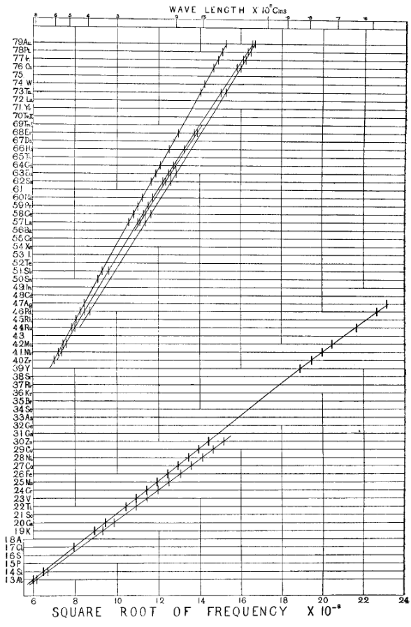

Z versus the square root of the K- and L-shell fluorescence frequency (From Mosely, <https://www.tandfonline.com/doi/full/10.1080/14786440408635141>) note the gaps for the then-unknown elements Tc (Z = 43), Pm (61), and Rh (75).

* Bringing together these two issues, the recognition of x-rays as quanta that could, in some cases, be emitted by electronic transitions involving deep shells of atoms resulted in the birth of x-ray spectroscopy. The work of Mosely <https://www.tandfonline.com/doi/full/10.1080/14786440408635141> and Siegbahn (Nobel address: <https://www.nobelprize.org/uploads/2018/06/siegbahn-lecture.pdf>) not only put x-ray spectroscopy of atomic transitions onto its earliest foundations but also led to the modern understanding of the periodic table, see <https://royalsocietypublishing.org/doi/10.1098/rsta.2019.0302>.
* These two videos also provide useful background and demonstration: Photoelectric effect calculation, https://www.youtube.com/watch?v=I_7ZfMlIKhk and photoelectric effect, and intuitive explanation, <https://www.youtube.com/watch?v=v-1zjdUTu0o>.

The above work establishes the fact that x-rays are photons, that photons are quantized, and that the x-ray part of the electromagnetic spectrum has the right photon energy to interact with the more tightly bound electrons in atoms. Having seen emission of x-rays from elements, work began on the time-reversed process, i.e., the absorption of x-ray by various elements. This resulted in the observation of an ‘absorption edge’ by Maurice de Broglie (brother of Louis de Broglie, famous for the wave hypothesis for all matter), <https://hal.archives-ouvertes.fr/jpa-00241894/document>, and then the first observation of K-edge fine structure by Fricke, <https://doi.org/10.1103/PhysRev.16.202>.

## 

## **I. Photoelectric effect:** Electromagnetic radiation (light) causes the emission of electrons (known as photoelectrons) from a material. The equation governing this process for the classic photoelectric effect is given by where is the energy of the incident photon, is the work function required to remove the electron from the material, and is the final kinetic energy of the emitted electron.

**Educational Goals**: Be able to understand and explain the fundamental process underlying x-ray absorption spectroscopy.

1. Give a description of the physics behind the work function, . What causes it to vary from material to material? What are some typical values for ?

An experiment is set up where a clean surface of Fe is exposed to a tunable monochromatic light source that can be used at three different intensities. The current of the escaping photoelectrons is plotted below as a function of the incident photon energy.

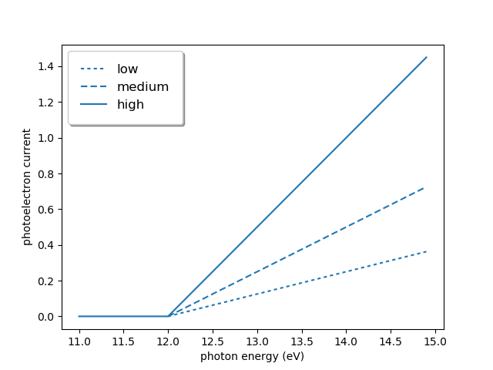

1. What is the physical significance of the different slopes in the data when the photon energy is greater than the threshold of 12 eV?
2. Why is no photoelectron current being detected below 12 eV? Why is this the case regardless of intensity (at least in this scenario)?

## **II. Absorption:** The photoelectric effect is also applicable on the atomic level, where instead of overcoming the work function of a material, a photon must overcome the binding energy of an electron in an atom. When an atom absorbs a photon of sufficient energy and an electron is emitted, the atom is left in an excited state. This is the underlying basis of x-ray absorption spectroscopies.

**Educational Goals**: Familiarization with the basic terms used to discuss absorption spectra. Introduce absorption edges and develop a qualitative understanding of the behavior of a standard absorption spectrum.

1. One of the most important equations in x-ray absorption, the Beer-Lambert law, is given below. is the incident intensity of the x-ray beam, and is the transmitted intensity of the x-ray beam after it passes through a sample of thickness with an absorption coefficient of . Graph as a function of for . Why must have units of inverse length?

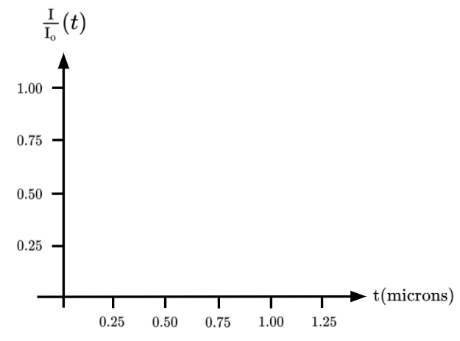

**Beer-Lambert Law:**

1. Go to the CXRO tool found at <https://henke.lbl.gov/optical_constants/atten2.html>. This will allow you to request tabulated data for the *attenuation length*, which is , of compounds. (WARNING: This means that you will have to take the *inverse* of the data the website gives you to get ). Use the website to get data for Ti, Fe, and Ni. To do this, set energy range 1000 eV to 30000 eV, steps to 500, and put the elemental name (ex: Ti) in the “Chemical Formula” box. An example of how you should fill out the boxes on the website is shown below. After you hit the “submit request” button, it will take you to a page with a plot of the requested data. Note that at the top of that page are the words “data file here” which if you click will give you xy version of the data. Make a single graph which includes for each element. How does the position of the jump in change between the elements, what is the trend?

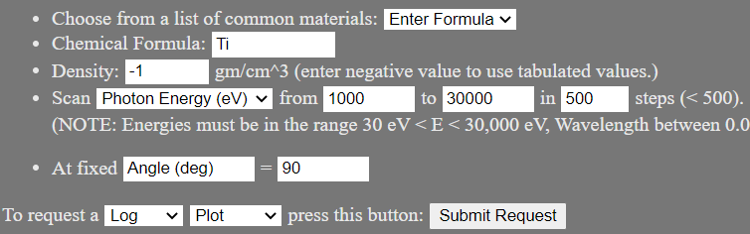

1. What is the physical meaning of the jumps in in your plot? Why does the energy at which the jump occurs change as it does with increasing atomic number?

1. In most plots you should observe noticeable jumps known as absorption edges. Using the CXRO again, graph for Pb (steps = 500, energy range 1000 eV to 30000 eV). You should get a plot like the one shown below. Now use the tabulated values found here <https://xdb.lbl.gov/Section1/Table_1-1.pdf> to correctly label each absorption edge. Note that in this context, these tabulated values for the absorption edges *are* the binding energies of the electrons in each shell of an atom.

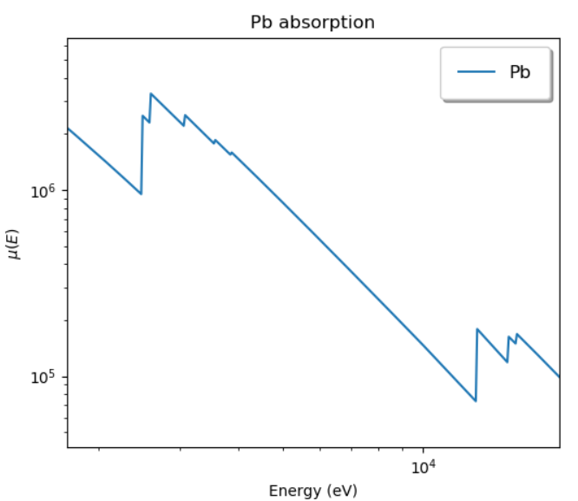

1. In the plot which you just labelled the ratios of just above an edge to just below an edge, for the L1, L2, and L3 edges of Pb, are [[L1, 1.12], [L2, 1.35], [L3, 2.45]]. The L1 edge corresponds to an electron in the 2s shell absorbing a photon. The L2 edge corresponds to an electron in the 2p1/2 shell absorbing a photon. Finally, the L3 edge corresponds to an electron in the 2p3/2 shell absorbing a photon. Explain why the L3 edge ratio is roughly twice as large as the L2 edge.
2. Download the data on pure Carbon from the CXRO tool you used earlier (steps = 500, energy range 1000 eV to 10000 eV) and plot the data on a log-log-scale. You will notice that there seems to be a power law relationship that governs the behavior when not near an absorption edge. Fit a curve to this data and report the exponential constant x ( that you find from your fit. Note that the value you find is approximately universal across the periodic table when at energies far from any absorption edge.
3. Next, use the CXRO tool <https://henke.lbl.gov/optical_constants/atten2.html> to calculate attenuation length for your favorite 3d transition-metal oxide compound, and remember to change the energy range as needed so that you can see all the edges. Create two separate plots, one for theof the compound you chose, and another for the of each of the elements in the compound. How do the positions of the edges in each graph compare? How might the concentration of one of the elements in the compound (such as CuO instead of CuO2) influence the relative edge magnitudes in the of the full compound?

## **III. Fluorescence:** After the x-ray is absorbed, the core hole that exists in the excited state will be filled by an electron from another, less tightly bound shell. To conserve energy, this transition must be accompanied by either emission of a fluorescence photon, the ejection of one or more electrons in Auger (IPA: ['o:ʒe], oh-ZHAY) processes, or (with low probability) combinations of the two. We’ll focus here on simple x-ray fluorescence, where one photon is emitted to conserve energy.

**Educational Goals**: Introduce notation commonly used to discuss transitions between bound states of an atom, along with further develop a student’s awareness of online databases and other resources.

1. Characteristic fluorescence lines correspond to electronic transitions within an atom and can sometimes have confusing notation. In this exercise, fill in the table with the correct notation, and then draw and label the corresponding spectral line on the diagram. See <https://en.wikipedia.org/wiki/Siegbahn_notation> for more details.

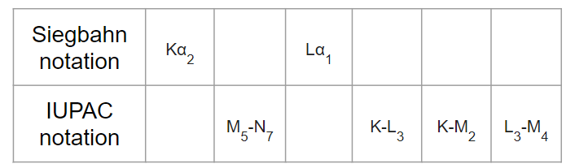

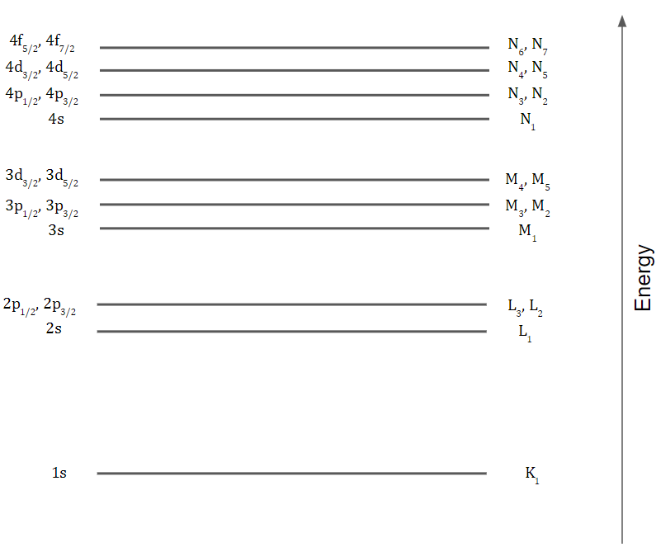

1. Go to the National Institute for Science and Technology (NIST)’s x-ray transition website at <https://physics.nist.gov/PhysRefData/XrayTrans/Html/search.html>. Using the ‘experimental’ column for energies, make a plot of the K1 fluorescence energy (K-L3) as a function of atomic number Z for elements Na to Ca. The trend you should observe is known as Moseley’s law and was one of the first definitive metrics for where elements belonged on the periodic table. You can learn more about Mosely’s law at <https://en.wikipedia.org/wiki/Moseley%27s_law>. You also may find it interesting to read Manne Siegbahn’s Nobel Prize address <https://www.nobelprize.org/prizes/physics/1924/siegbahn/speech/>.
2. For a few of your favorite elements available on the above NIST website, look at all transitions listed. For some transitions there are theoretical values, but no experimental values. What transitions are these, and what might be the reason these transitions have not been experimentally observed? (Hint: Consider the selection rule at play, and the relationship between the wavelength of the light being emitted and the physical size of the atom it is being emitted from.)